Transmissible Spongiform Encephalopathy (Protein folding)
Markus Gerstel, 11th Nov 2010
Transmissible Spongiform Encephalopathy describes one specific group of diseases, that, together with Alzheimers, ALS (disputed, and may only account for 2% of the cases), Huntington’s disease and Cystic Fibrosis, are classidied as protein misfolding diseases (proteopathies)^{[1, tbl. 11.1]}. The group of TSE-diseases is also called prion diseases, and currently both terms are used interchangeably. That however can lead to misunderstandings, as not every form of TSE is transmissible, and not every form is spongiform. The ICD-10 classification, for historic reasons, puts TSE into the category A81: ‘atypical virus infections of central nervous system’. It is reasonable to expect the taxonomy to change in the future, as our knowledge of prion diseases increases.

There are more than 8 known prion diseases. They differ from normal diseases in that they are both heritable and transmissible. Scrapie has first been described in sheep in 1730. The transmissibility has been shown on a large scale in the late 1930s, when a vaccine carrying the scrapie prion was distributed to 18.000 sheep. Creutzfeldt and Jakob described cases of TSE in humans in 1920 and 1921^{[2]}. All known human forms of TSE affect the same protein, PrP^{C}. This is a highly conserved protein, that is, with few mutations, also found in cows, sheep, hamsters and
mice, and is also involved in BSE and scrapie. Another shared feature of all TSEs is that they are 100% fatal, and they have a very long incubation time, sometimes decades.
The outbreak of the BSE epidemic (cf. Fig. 1) in 1986 caused a surge of research into prion diseases. As a reaction, the U.K. banned the feeding of ruminant proteins (e.g. cattle and sheep) to ruminants in July 1988. With an average incubation time of 4-5 years the number of confirmed BSE cases peaked in 1992. New knowledge about the nature of BSE, the strong inactivation resistance of prions and the risk of cross-contamination lead to further bans in 1995 and 1996. The number of cases has been declining steadily, there have been 12 reported cases in 2009. The risk of BSE seems to be controllable.^{[3]}
Fig 1: BSE incidents in the U.K. ^{[3]}
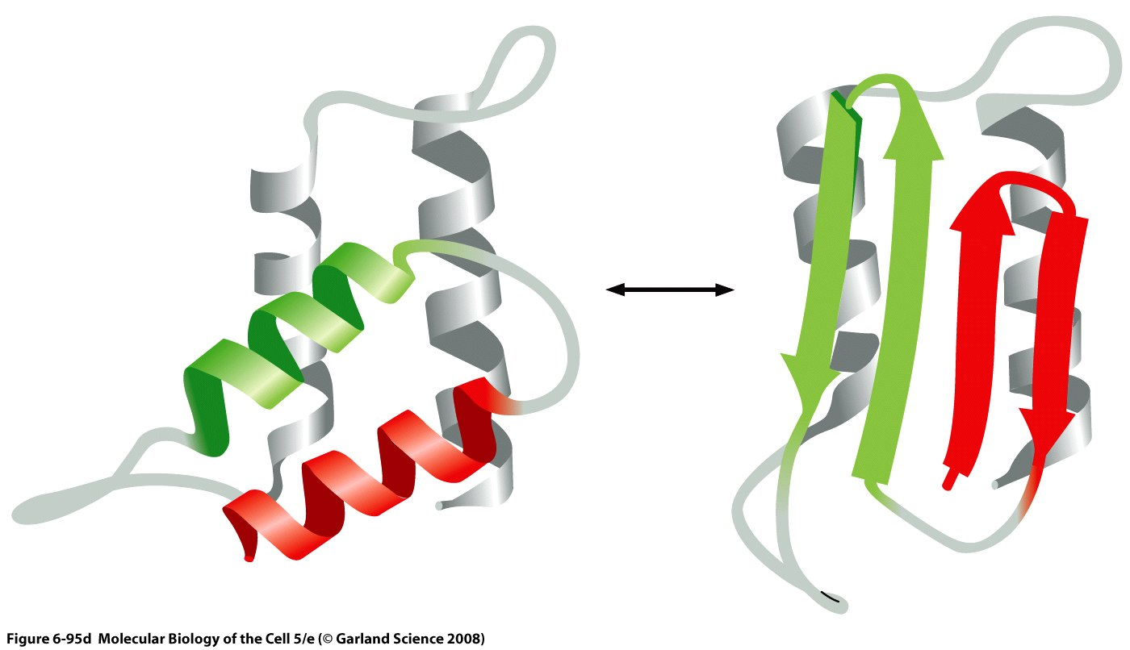
Fig 2: Model of different PrP^{C} (left) and PrP^{Sc} (right) structures.
Two alpha-helixes are converted to β-sheets. ^{[9]}
Prion disease in humans is a bit of a different story: Fatal Familial Insomnia (FFI), Gerstmann-Sträussler-Schenker (GSS) syndrome and familial CJD are all caused by heritable, autosomal dominant defects in the PRNP gene that encodes the PrP^{C} protein. So while the identification of families carrying those gene defects is easy, the culling of those families is ethically debatable. Even preimplantation genetic diagnosis is a hot topic, so removing those diseases from the gene pool is not an option for the foreseeable future. Due to the long incubation time of these diseases, they will also not disappear by themselves. By contrast some forms of TSE, e.g. sCJD, can appear spontaneously without any known genetic predisposition. The search for a cure to those diseases, as for all TSEs in general, has been unsuccessful so far. ^{[1]}
Characteristic symptoms of TSEs include dementia (loss of cognitive ability), ataxia, myoclonus (loss of muscle control, twitching), weight loss, and, in animals, behavioural disorders. Post-mortem analysis may show spongiform degeneration of the brain, diffuse or focally clustered small, round vacuoles caused by neuronal apoptosis, and astrogliosis. Some, but not all forms of TSE, include amyloid deposition, that on further examination prove to consist of a highly Proteinase-K resistant protein. It has since been shown that this protein, dubbed PrP^{Sc} (Prion Protein, Scrapie isoform - but the name PrP^{Sc} is now used for all unnatural PrP isoforms, independently of scrapie) has a primary structure corresponding to PrP^{C}. It however has a much higher β-sheet content than the mostly alpha-helical, natural PrP^{C} (Prion Protein, cellular isoform). The β-sheet structure leads to tight binding of PrP^{Sc} to amyloid fibers that cannot be broken down easily.^{[1]} This leads to a strong Proteinase-K resistance and difficulties in inactivation: Autoclaving at 133°C and 3 bar for 20 minutes (instead of the usual 3 minutes) destroys prions only if high-risk tissues (brain, spinal cord) are reliably excluded from the process^{[10]}. PrP^{Sc} also proves to be unexpectedly resistant to UV light and harsh chemical treatment^{[2]}, which helped the prion spread in the BSE epidemic^{[2,10]}.
The exact natural function of PrP^{C} is, as of yet, unknown. PrP^{C} is a membrane protein that can be found in lipid rafts or caveola. It may take part in several signalling pathways, including the ERKs pathway that may promote apoptosis^{[1]}. In vitro experiments show that PrP^{C} may also protect neurons from apoptosis^{[4]}. Transmembrane forms of PrP^{C}, called ^{CTM}PrP have been reported in some inherited cases of prion diseases^{[5,6]}. Similarly the exact function of PrP^{Sc} has not yet been established. It seems likely that the introduction of PrP^{Sc} induces stress to the endoplasmic reticulum, which causes a release of calcium ions. These then activate Caspase-12 which in turn activates Caspase-3 which leads to cell apoptosis^{[1]}.

It is certain that PrP^{Sc} presence enables the production of PrP^{Sc} from natural PrP^{C}, although the exact mechanism is still unknown. It is established that this process can happen in the brain, and it seems that this process is facilitated by lipids and polyanions^{[7,8]}. Simultaneously PrP^{Sc} inhibits the possible reversion of PrP^{Sc} to PrP^{C} by forming strong amyloid plaques. A simple interaction model is shown in Fig. 3. The positive feedback mechanism explains why some cases of TSE lead to a relatively quick death after a long incubation period. This self-propagating, viral-like on a molecular level, nature of prions explains why genetically heritable TSEs are dominant: In theory one single molecule of PrP^{Sc} at the right time and the right place will lead to the outbreak of the disease. The heritable variants of TSE (FFI, GSS, fCJD) depend on a mutation in the PRNP-gene leading to a modified PrP^{C} with an increased likelihood to form PrP^{Sc} without the presence of any PrP^{Sc} seed. Yet this structurally different PrP^{Sc} can still infect hosts with am unaffected PRNP-gene and therefore the 'correct' PrP^{C}. Similarly PrP^{Sc} can also jump across species barriers. One theory postulates that BSE originated from scrapies.^{[1,2,7]}
Fig 3: Simplified interaction model
between PrP^{C} and PrP^{Sc}

Research on prions proved to be difficult on different levels: Firstly prions, infectious molecules, were an entirely new concept, that was met with much scepticism. Secondly, detection of a small number of prions is very difficult. Established procedures work on DNA (PCR) and RNA (RT-PCR) but not directly on proteins^{[1]}. Yet in theory a single molecule is enough to infect the whole organism. Thirdly, long incubation times made it very difficult to find past connections between subjects. Additionally there is no immunoresponse, and there are no antibodies to be found. Detection in vivo is therefore only possible after the onset of symptoms – by which time the subject may already have been infecting others for years, as was the case in a few human growth hormone donors^{[2]}. Finally the concentration of PrP^{Sc} is very high in brain tissue, but very low in blood and other easily reachable (and expendable) tissue.

One important step for prion diagnostics and research was the discovery of Protein Misfolding Cyclic Amplification (PMCA) by G.P. Saborio et al. in 2001^{[11]}, shown in Fig. 4. By exploiting the inherent self-reproducing capabilities of prions it is now possible to amplify a few existing PrP^{Sc} molecules to measureable levels: The solution to be tested is put into a surplus of pure PrP^{C}. Incubation periods are interrupted by sonification periods that break up some β-sheet amyloid complexes that have already formed. This results (theoretically) in an exponential growth of numbers of PrP^{Sc}-seeds, and therefore conversion of free PrP^{C} to PrP^{Sc}. Experiments showed that for this reaction to take place there are additional components needed. It was already speculated that a catalyst, or conversion factor, protein X is facilitating the creation of new PrP^{Sc} ^{[1, Fig 3.3]}. Since this component has not been identified yet, one way to force the reaction to happen is by introducing material that is known to contain component X: Brain homogenate from healthy unaffected brains^{[1, p. 117]}.

Fig 4: Protein Misfolding Cyclic Amplification. PrP^{C} attaches to PrP^{Sc} seed and leads to amyloid
deposit. Deposit is periodically broken up by sonification to increase available seed surface and
speed up reaction. Inspiration from ^{[1]}, p.116

PMCA allowed research to continue at a much higher pace – there was no longer a need to wait for animals to develop symptoms of TSE to detect low levels of the prion. The search for a cure to TSEs is still ongoing. One possible therapheutic target that has recently been identified in animals is Calcineurin inhibition^{[13]}. But currently all TSEs are still inevitably fatal. Meanwhile a few of the studies that used PMCA came up with results that may change our understanding of prions yet again: In 2009 Barria M.A. et. al. produced new strains of PrP^{Sc} (de novo) with yet another new misfolding, that resulted in new disease phenotypes^{[12]}.

Due to time and space constraints this essay can not hope to mention all aspects of modern prion research. But the author may hope to give the reader the idea that there are still many more unresolved questions about prions. It is still unresolved what PrP^{C} really does in organisms. PrP-knockout mice seem to live quite happily. PrP^{Sc} by itself is not neurotoxic. PrP-knockout mice, when injected with PrP^{Sc}, do not develop TSE^{[1]}. PrP^{Sc} can be found in uninfected human brains that do not develop TSE^{[14]}. Finally there is not just one strain of PrP^{Sc}, but a lot of different conformations. These conformations are subject to mutation and selective amplification, in other words: Darwinian evolution^{[15]}.

[1] Soto C., 2006, Prions - The New Biology of Proteins, Taylor & Francis, 167 p., ISBN 0-8493-1442-9.
[2] Ridley R.M., Baker H.F., 1998, Fatal Protein, Oxford University Press, Oxford, 249 p., ISBN 0-19-852435-8.
[3] Data from the World Organization of Animal Health, OIE, 2010, http://www.oie.int/eng/info/en_esbru_original.htm
[4] Bounhar Y., et al., 2001, Prion protein protects human neurons against Bax-mediated apoptosis, J. Biol. Chem., 276, 39145-39149.
[5] Hedge R.S., et al., 1998, A transmembrane form of the prion protein in neurodegenerative disease, Science, 279, 827-834.
[6] Hedge R.S., et al., 1999, Transmissible and genetic prion diseases share a common pathway of neurodegeneration, Nature, 402, 822-826.
[7] Brown P., 2008, Transmissible spongiform encephalopathy in the 21st century, Neurology, 70, 713-722.
[8] Deleault N.R., Harris B.T., Rees J.R., Supattapone S., 2007, Formation of native prions from minimal components in vitro, Proc. Natl. Acad. Sci., USA, 104, 9741-9746.
[9] Alberts B., et al., 2002, Molecular Biology of The Cell, 5th edition, 1268 p., ISBN 0-8153-4106-7.
[10] Taylor D.M., Woodgate S.L., 2003, Rendering practices and inactivation of transmissible spongiform encephalopathy agents, Rev. Sci. Tech. OIE, 22 (1), 297-310.
[11] Saborio G.P., Permanne B., Soto C., 2001, Sensitive detection of pathological prion protein by cyclic amplification of protein misfolding, Nature, 411, 810-813.
[12] Barria M.A., Mukherjee A., Gonzalez-Romero D., Morales R., Soto C., 2009, De Novo Generation of Infectious Prions In Vitro Produces a New Disease Phenotype, PLoS Pathog 5(5): e1000421. doi:10.1371/journal.ppat.1000421
[13] Mukherjee A., Morales-Scheihing D., Gonzalez-Romero D., Green K., Taglialatela G., Soto C., 2010, Calcineurin Inhibition at the Clinical Phase of Prion Disease Reduces Neurodegeneration, Improves Behavioral Alterations and Increases Animal Survival, PLoS Pathog 6(10): e1001138. doi:10.1371/journal.ppat.1001138
[14] Yuan J., Xiao X., McGeehan J., Dong Z., Cali I., Fujioka H., Kong Q., Kneale G., Gambetti P., Zou W.-Q., 2006, Insoluble Aggregates and Protease-resistant Conformers of Prion Protein in Uninfected Human Brains, J. Biol. Chem. 2006 281: 34848-34858. First Published on September 20, 2006, doi:10.1074/jbc.M602238200
[15] Li J., Browning S., Mahal S.P., Oelschlegel A.M., Weissmann C., 2010, Darwinian Evolution of Prions in Cell Culture, Science 327 (5967), 869. [DOI: 10.1126/science.1183218]

